Petition for Legal Name Change

Petition for Legal Name Change
IN THE SUPERIOR COURT OF THE STATE OF SAN ANDREAS
COUNTY OF LOS SANTOS / BLAINE COUNTY

Petitioner:
PETITION FOR CHANGE OF NAME
Comes now, the above Petitioner, to respectfully petition this Honorable Court to legally change their name and states the following:

- Current Legal Name: PRINTED NAME
- Requested New Name: PRINTED NAME
- Date of Birth:
- Reason for Change:
- Marriage
- Divorce
- Personal Identity
- Petitioner affirms that this request is not made for fraudulent purposes and does not intend to avoid debts, criminal liability, or civil obligations.
- Petitioner requests the Court to issue an Order Granting Legal Name Change.

Respectfully submitted this 00 day of _________, 20__.

Signature: Signature of Petitioner
Contact Number:
Current Address:

Order of the Court
The Above Petition for Change of Name is hereby GRANTED / DENIED.
Dated this ____ day of _________, 20__.

Signature of Judge
Hon. Judge
Superior Court of San Andreas

Petition for Stay of Name Change

IN THE SUPERIOR COURT OF LOS SANTOS COUNTY OF LOS SANTOS, STATE OF SAN ANDREAS
In re the Name Change of:
[Current Legal Name]
Petitioner.

PETITIONER'S MOTION TO STAY AND RESCIND ORDER GRANTING NAME CHANGE
COMES NOW the above named Petitioner, and respectfully moves this Court to stay and rescind the previously entered Order Granting Name Change in the above-captioned matter. The Petitioner acknowledges that the name change was lawfully approved by this Court; however, due to a material change in the circumstances that originally formed the basis of the Petition, the Petitioner requests that the Order be vacated and the name change nullified in its entirety.

IDENTIFICATION OF PRIOR PETITION
  - Date of Original Petition:
  - Date Order Was Granted:
  - Name Granted Under Order:
  - Original Basis for Petition:
- Marriage
- Divorce
- Personal Identity

GROUNDS FOR WITHDRAWAL AND STAY
The Petitioner moves to rescind the approved Order on the following grounds. Please select the applicable basis below. The selected ground must correspond to the original reason the Name Change was petitioned:
- IF ORIGINAL BASIS WAS MARRIAGE:
- The marriage did not proceed; the Petitioner and the other party separated prior to solemnization.
- The Petitioner has reconciled under their prior legal name and no longer wishes to adopt the married name.
- IF ORIGINAL BASIS WAS PERSONAL IDENTITY:
- The personal circumstances that motivated the identity-based name change have materially changed.
- The Petitioner wishes to retain their original legal name and affirms that no legal or personal obligation compels the name change.

LEGAL EFFECT OF RESCISSION
Upon acceptance of this Stay and Rescission by the Court, the following shall take effect:
- The Order Granting Name Change identified in Section I is hereby VACATED and shall be of no further legal force or effect as of the date this Motion is approved by the Court.
- The Petitioner's legal name shall revert to the name held prior to the issuance of the Order, as identified in Section I above.
- No government agency, court, institution, or third party shall implement, record, or publish the name change set forth in the vacated Order.
- All agencies and offices previously notified of the name change are hereby directed to reverse any updates made pursuant to the vacated Order.
- The Petitioner retains the right to file a new Petition for Name Change at a future date in accordance with applicable San Andreas law.

PETITIONER'S DECLARATION
I declare under penalty of perjury under the laws of the State of San Andreas that the foregoing is true and correct, that I am the Petitioner of record in the abovecaptioned matter, that the name change Order was previously granted by this Court, and that I am voluntarily and of my own free will moving to stay and rescind said Order based on the grounds identified in Section II.
Sign of Petitioner Here
Signature of Petitioner Date

PRINT NAME
Printed Legal Name (Current) Phone Number

COURT CLERK'S ACKNOWLEDGMENT AND APPROVAL
The undersigned Court Clerk of the Superior Court of Los Santos hereby acknowledges receipt of the foregoing Motion to Stay and Rescind Approved Name Change Order, and certifies:
- The Motion has been reviewed and determined to be facially sufficient under San Andreas Civil Code.
- The court record has been updated to reflect the pendency of this Rescission Motion.
- No name change shall be further implemented or recorded pursuant to the stayed Order.
- A copy of this filed document shall be provided to the Petitioner as confirmation of filing.
Signature of Clerk Here
Signature of Clerk

PRINT NAME
Printed Name of Court Clerk

Date Received & Filed:

Marriage Petition (Civil)

Petition For Marriage
IN THE SUPERIOR COURT OF THE STATE OF SAN ANDREAS
COUNTY OF LOS SANTOS / BLAINE COUNTY

We, [Petitioner Name] and [Petitioner Name], hereby respectfully petition the court for recognition and record of our lawful marriage, solemnized within the State of San Andreas.
The petitioners affirm that they are entering into this marriage willingly, lawfully, and without coercion, and request that the Court acknowledge and record their union.

Petitioner 1: [Printed Name]
Signature: Signature
Date: 00/00/20__
Petitioner 2: [Printed Name]
Signature: Signature
Date: 00/00/20__

Date of Intended Solemnized Marriage: 00/00/20__
Location of Ceremony: Postal
Name of Officiant: PRINTED NAME

Clerk of Court

Petition for Marriage License Granted / Denied.
Dated this ____ day of _________, 20__.

Clerk Signature
Court Seal:

Marriage Certificate Instruction

Marriage Certificate Instructions
The clerk or Judge will fill out the upper portion of the certificate and the officiant will complete the bottom portion at the time of the ceremony. Then it should be submitted to the Bride and Groom and submitted to the docket.

Ensure as an attorney the Officiant is notified and given the copy to work with. Submit the Certificate Template with the Name changes and Marriage Petition.

Marriage Certificate
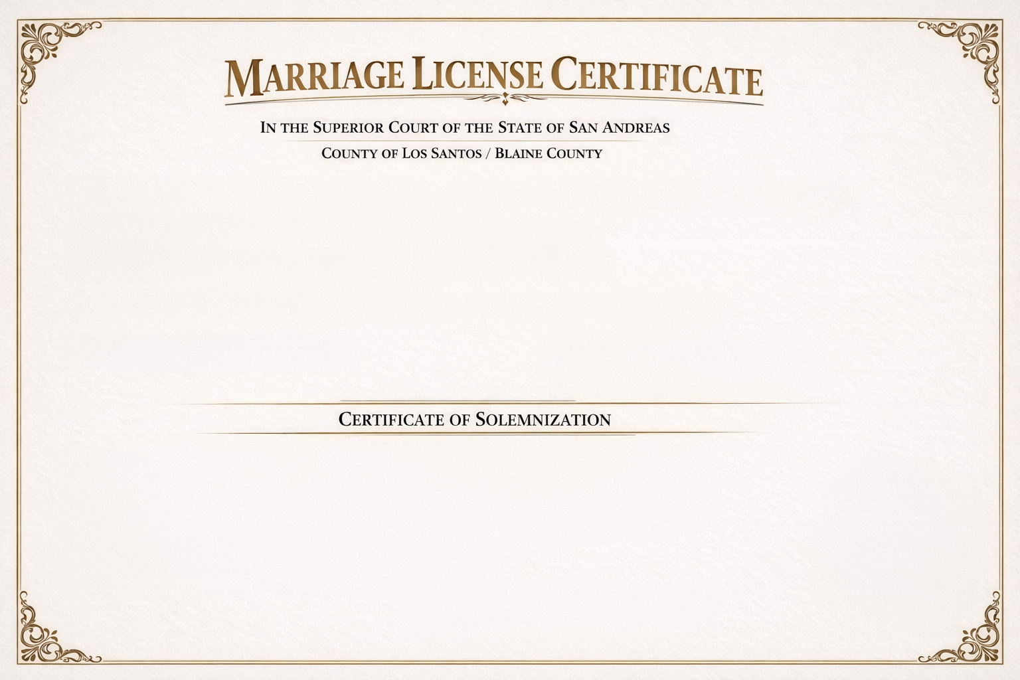

This certifies that a Marriage License was issued on the 00th day of Month , 2026, to:
Name : _Printed Name_______
Name: _Printed Name_______
The above-named individuals are authorized by the State of San Andreas to be joined in marriage according to law.
Issued by: Printed Name
Clerk of the Court
Signature
Clerk Signature

I hereby certify that the above-named parties were lawfully joined in marriage on the 28th day of March , 2026.
Location of Ceremony: __Postal Address______ Witness: __Printed Name
Name of Officiant: _Printed Name________ Signature of Witness: __Signature _
Signature of Officiant: Signature

Petition for Divorce

Petition for Divorce
IN THE SUPERIOR COURT OF THE STATE OF SAN ANDREAS
COUNTY OF LOS SANTOS / BLAINE COUNTY

Petitioner:
Respondent:
PETITION FOR DISSOLUTION OF MARRIAGE
- The parties were lawfully married on _____________.
- The marriage is irretrievably broken due to irreconcilable differences.
- There are no minor children of this marriage.
- Petitioner requests:
- Dissolution of marriage.
- Restoration of maiden/former name
- Division of shared property (if any)
- Other relief deemed just and proper
Respectfully submitted this _____ day of _________,20__.

Petitioner Signature: Signature of Petitioner

Order of the Court

The Court hereby GRANTS the dissolution of marriage.
Both parties are restored to single status effective immediately.

Dated this ____ day of _________, 20__.

Signature of Judge
Hon. Judge ___________
Superior Court of San Andreas

Last Will and Testament

Last Will and Testament
IN THE SUPERIOR COURT OF THE STATE OF SAN ANDREAS
COUNTY OF LOS SANTOS / BLAINE COUNTY

LAST WILL AND TESTAMENT OF (FULL NAME)
I, [Full Legal Name], of [City, San Andreas], being of sound mind and disposing memory, do hereby make, publish, and declare this to be my Last Will and Testament.

- REVOCATION: I revoke all prior will and codicils.
- PERSONAL INFORMATION:
  - Date of Birth:
  - Address:
- EXECUTOR: I appoint [Name] as Executor of this Will.If they are unable or unwilling to serve, I appoint [Alternate Name].
- BEQUESTS:
  - To [Name}, I leave [Item/Amount/Property].
  - To [Name}, I leave [Item/Amount/Property].
  - (Continue as needed)
- RESIDUARY ESTATE: All remaining assets shall be distributed to [Name or Charity].
- BURIAL/FINAL WISHES:

Signatures: Testator Signature
Signed this _____ day of _______, 20__.
Witnesses:
- Signature of Witness 1
Printed Name
- Signature of Witness 2
Printed Name

Clerk Signature: Signature

Restraining Order

Restraining Order Request
IN THE SUPERIOR COURT OF THE STATE OF SAN ANDREAS
COUNTY OF LOS SANTOS / BLAINE COUNTY

Petitioner (Person Seeking Protection);
Full Name:
DOB:
Address:
Phone/Contact:

Respondent (Person to Be Restrained):
Full Name:
DOB (if known):
Last Known Address:
Occupation / Employer (if known):

- TYPE OF ORDER REQUESTED
- Temporary Restraining Order (TRO)
- Permanent Restraining Order (PRO)
- Emergency Protective Order (EPO)
- GROUNDS FOR THE ORDER
Petitioner respectfully represents to the Court that the Respondent has:
- Cause or threatened physical harm
- Engaged in stalking, harassment, or intimidation
- Made credible threats to safety or wellbeing
- Cause emotional or psychological distress
- Other:

Incident Summary:
(Provide detailed description of events leading to this request, including dates, locations, and any witnesses.)

- RELIEF REQUESTED
Petitioner requests the Court to issue an order:
- Prohibiting Respondent from contacting Petitioner directly or indirectly
- Requiring Respondent to remain at least ____ feet away from Petitioner, their home, workplace, or vehicle.
- Requiring Respondent to surrender all firearms or weapons
- Other conditions the Court deems necessary for safety

- EVIDENCE / SUPPORTING MATERIALS
- Police report(s) attached
- Witness statement(s) attached
- Photographs, texts, or recordings attached
- Medical documentation (if applicable)
- Other:

- AFFIRMATION
I affirm that the statements in this petition are true and correct to the best of my knowledge and belief. I understand that providing false information to the Court may constitute perjury.
Signatures of Petitioner: Signature
Signed this _____ day of _______, 20__.
Sworn and Subscribed Before:
Clerk /Notary: Signature
Printed Name
Date:

